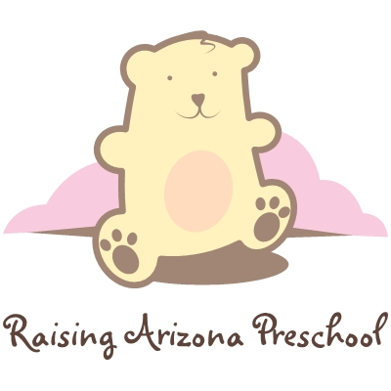

Qualifications of Raising Arizona Preschool Management

Exemplifies Leadership attributes
- Leads by example (ie: works the hardest & longest, at the toughest, dirtiest jobs)
- Inspires teachers to do better through example, compliments, service, & constructive criticism when necessary.
- Gets to know all the teachers and where they excel and where they struggle, and makes plans to help each individual reach personal and professional goals.
- Is always happy & approachable, never brings personal problems to work.
- Sets personal & professional development goals to consistently refine personal attributes and skill sets.
- Understands that power is not derived by virtue of a title, but through example, persistence, service, and love.

Knowledge of Early Childhood Education
- Understands Narrative and that we are writing the stories of these childrens lives.
- Understands the different curriculum types out there, (ie: Emergent, Creative, Montessori, & Theme-based) and what curriculum we use and why we use it.
- Has working knowledge and implementation skills of the various curriculum types and can speak from experience about each and their pro’s and con’s.
- Has a strong desire to further their education in early childhood, and always is observing, and learning what works and doesn’t with each child.
- Understands how children learn, and what they should know by what age, and can easily identify when a child is behind or ahead of the curve and can appropriately bring this to the knowledge of the parents without offense.
- Can create & implement a plan of action for children with discipline problems, and effectively communicate the plan with parents and the child.

Working knowledge of State rules and Regulations & Center Philosophy
- Has working knowledge of the CACFP program.
- Has working knowledge of DES paperwork.
- Understands the DHS rules and regulations, and can effectively communicate them to the staff.
- Understands our Philosophy on Early Childhood Education.
- Understands how our center is different than the competition and effectively communicates that difference to Parents.

Growing the Center
- Is 100 % committed to the growth of the Center.
- Plans community outreach events, and marketing efforts to increase enrollment.
- Knows how to give a tour with salesman-ship, and demonstrates professionalism and knowledge of Core Preschool Fundamentals.
- Is deeply concerned about potential problems with parents and any complaints, and does their best to apologize profusely, and (with the parents) establishes action plans to solve the problems & make the parents feel at ease.
- Keeps track of the children’s attendance patterns and works to increase attendance and makes appropriate calls when kids “go missing” for a few days, always encouraging them to come to the center as much as possible.
- Gets to know the community establishing win/win relationships with nearby teachers and principles and neighboring businesses by going to visit them and getting to know management and establishing effective business relationships.
- Understands a P&L statement, and manages income and expenses including payroll effectively.

Exemplifies Customer Service Excellence
- Greets parents & Children by name with a purpose, and with a smile.
- Communicates with a Friendly tone, using appropriate body language, understanding that tone and body language do 90 % of the communicating.
- Understands the importance of incoming phone calls, answers the phone with a smile, and uses salesman-ship to get new families in the door.
- Shows through all they do that the customer is really their boss, doing anything they need, going out of the way to make their day better.
- Delivers heartfelt and honest thanks for allowing us to serve them.

